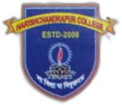***H A R I S H C H A N D R A P U R C O L L E G E*** P.O.- PIPLA, DIST.- MALDA, PIN.- 732125, Mob.- 8768130356

Ref.No.- August/2020/03 Date:- 06/08/2020

*N O T I F I C A T I O N*

It is hereby notified that the students of the college are asked to inform the college through E-mail about various problems or issues related to their Registration or Results (if any) by 9th August, 2020.

Sd/-

Dr. Arnab Chatterjee

Teacher-in-Charge Harishchandrapur College, Malda.